**ME6406 HW4 Thanakorn Khamvilai Report**

Problem 1: Artificial Neural Network (ANN)

1-1) Derive the weight update rule for the ANN (using a **bipolar** sigmoid function for all the processing elements).

Solution:

1-2) Solution: NN_training.m

For this neural network training, there are 3 layers, an input layer, one hidden layer, and an output layer. There are 49 inputs representing each pixel of the training images. There are 49 nodes in the hidden layer. There are 4 outputs representing each letter ‘M’, ‘E’, ‘1’, and ‘7’.

The linear activation function h(f) = f is used for the input layer. The sigmoid function is used for the hidden layer and the output layer.

The cost function J = 1/16*sqrt… (mean squared error) and is shown in the figure below.

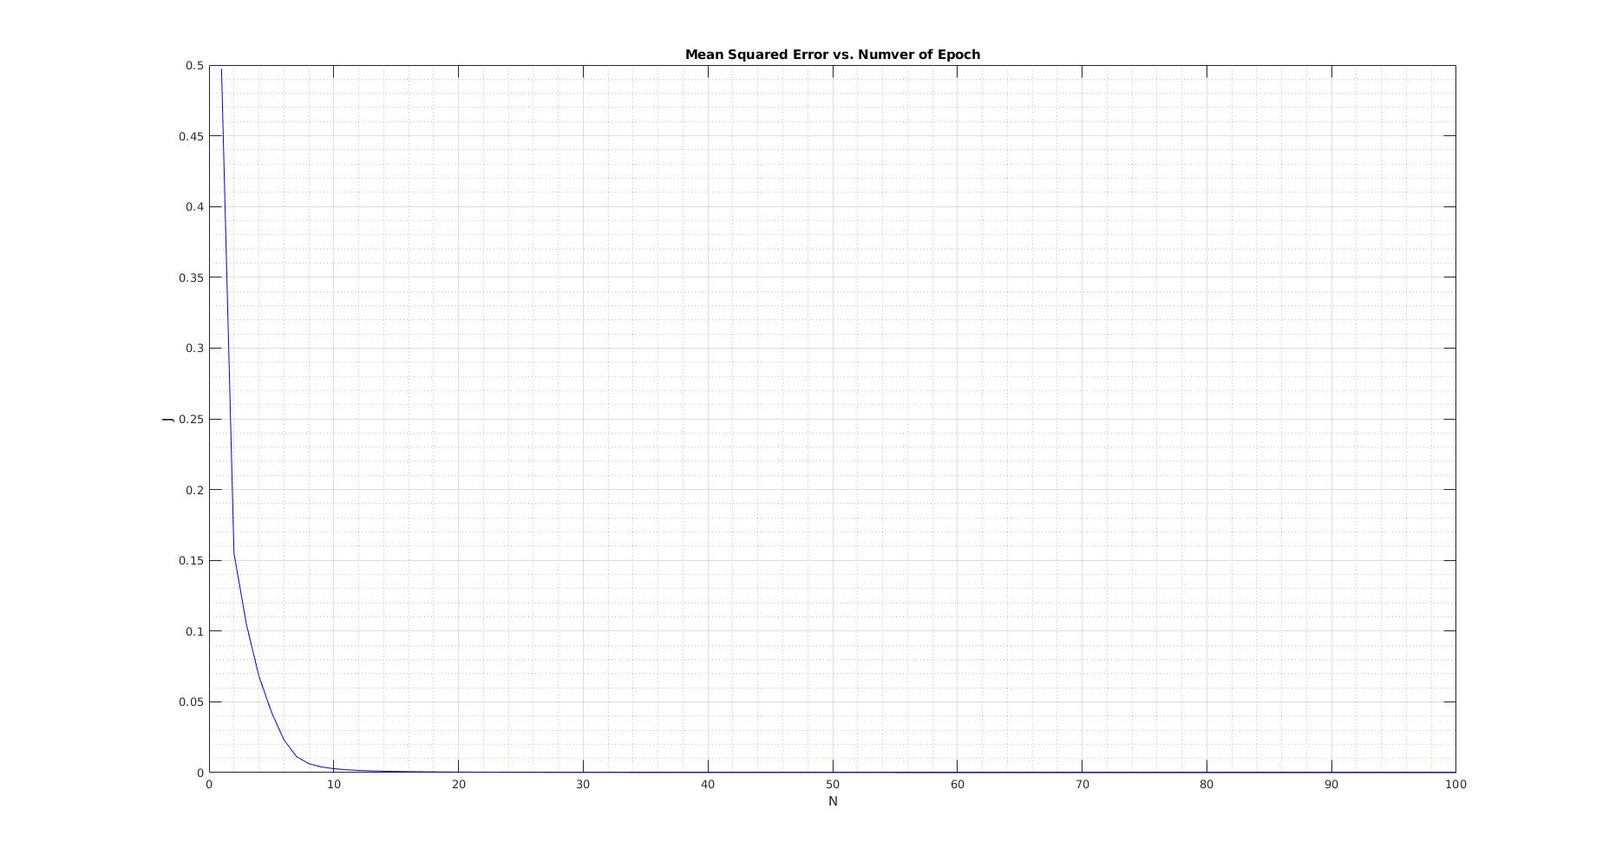 To train the data set, both forward and backward propagation were performed.

The training model was run for 100 epoch, and the cost function is decreasing for each every epoch.

The resulted weights of each node were saved in the file NN_weights.mat.

1-3) Solution: NN_test.m

To test the data, only the forward propagation was performed. The resulted before rounding are shown in the table below.

|  |  |
| --- | --- |
|  | Output vector |
| M | [0.9967 0.0014 0.0008 0.0019] |
| E | [0.0047 0.9913 0.0009 0.0015] |
| 1 | [0.0004 0.0006 0.9988 0.0004] |
| 7 | [0.0092 0.0030 0.0004 0.9863] |

After rounding,

|  |  |
| --- | --- |
|  | Output vector |
| M | [1 0 0 0] |
| E | [0 1 0 0] |
| 1 | [0 0 1 0] |
| 7 | [0 0 0 1] |

Problem 2: Pose Estimation and Stereo Vision

2a) Camera Model Solution: CameraModel.m

From the translation, we know that the centroid of both camera is at Z = 8; hence, the depth of each feature point can be calculated by Z-Zw

Since the problem tells us that the cameras are rotated by Rx, translated by T, then rotated again by Ry, the final equation will be

[X,Y, Z]’ = Ry*(Rx{Xw, Yw, Zw] + T)

[… expand…]

where

Therefore, the camera I coordinate will be

and the camera II coordinate will be

Since, the focal length of both camera is the same, the image I, and II coordinate can be calculated from the following equations, respectively.

The results of each feature point in each coordinate are shown in the table below.

2b) Pose Estimation Solution: PoseEstimation.m

2c) Stereo Vision (Parallel) Solution: StereoVisionParallel.m

2d) Stereo Vision (General) Solution: StereoVisionGeneral.m

Problem 3: Color

3a) Artificial Color Contrast (ACC) Solution: HW4_3a.m

3b) Principle Component Analysis (PCA) Solution: HW4_3b.m

3c) Color-Based Image Segmentation Solution: HW4_3c.m